FACULTY EVALUATION
Programme Name: Social Entrepreneurship Program (SEP)- START MASTERCLASS Uganda (26th January 2026 - 30th January 2026)
Session: Business Plan reviews
Faculty Name: Dr. James onyoin
No. of Respondents: 4
No. of Participants: 10
Evaluation Parameter | (%) Individual Score | (%) Programme Average
Punctuality (Commencement and Completion of Sessions) | 90 | 88
How well do you understand the core concepts presented? | 75 | 83
Rate your confidence in applying the new skills learnt | 65 | 78
Degree of Faculty preparedness for the sessions | 85 | 91
Content and methodology of the program | 80 | 87
Quality of class and group discussions | 70 | 82
The information presented in the course is relevant to my work (ministry) | 90 | 91
Average scores | 79 | 86

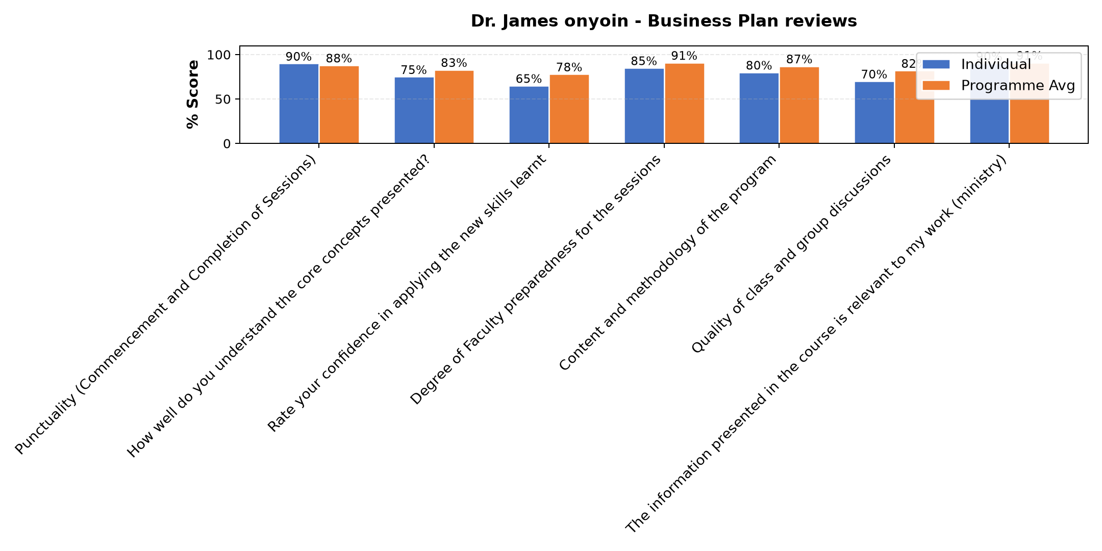

Comments & Feedback
- • Networking
- • Was not on site
- • Thank you so much for the opportunity you granted to us by sharing with us
- • Thank you for imparting us with the knowledge as well as our Enterprise is concerned
SUBMITTED THROUGH:
SBS Evaluation Automation System

